Towards a Refinement of Natural Filament Composition in Artificial Ossification for Bone-inspired Construction of Technical Structures #134, the title should not be longer than 70

Towards Artificial Ossification for Bone-inspired Technical Structures #70

R.Starke & I. Vukorep

*Chair of Digital Design Department, BTU Cottbus-Senftenberg, Germany, starke@b-tu.de,*

K. Frommelt

*DFG Research Training Group 1913, BTU Cottbus-Senftenberg, Germany, konrad.frommelt@b-tu.de*

A. Melcher

*Niessink Engineering GmbH, Germany, alex-melcher@gmx.de*

T. Hinze

*Department of Bioinformatics, Friedrich Schiller University Jena, Germany, thomas.hinze@uni-jena.de*

ABSTRACT

1. INTRODUCTION

1.1 *Natural Ossification*

Ossification is a biological process that constantly restructures bone structures in reaction to the applied loads. This was first described in Wolff’s law (reference) and shows for instance in the bone resorption experienced by astronauts. By this process, the balance between stability and material usage in the bone tissue is permanently adjusted during its lifetime. Tube bones in mammal skeletons, like femur or humerus, consist of an outer shell, the cortical bone, and a porous inner framework, the trabecular bone. The simulation of this porous framework’s adaptability is at the core of this research. There are two main agents which are essential for its adaptability: *osteoblast* cells, which mineralize bone tissue in areas of high stress, and osteoclast cells, which demineralize tissue in areas of low stress. The tissue consists of ossein fibers, a kind of collagen, of high strength and elasticity (reference).

Existing biological simulations of osteoblasts and osteoclasts, called co-culture systems, focus on correct simulation of cell interactions and collagen fiber array on a molecular level. The proposed method’s novelty lies in the strong focus the spatial relations and results. Downward from the 6th level of organization, the trabecular architecture, visible to the naked eye, described in *the material Bone* [reference], the biological processes are meaningfully translated into spatial operations. The result is a new lightweight shape and size optimization algorithm, capable of dynamically visualizing ossification principles, including osteoblast and osteoclast movement.

1.1 *Bionics*

The analysis and adaptation of biological processes and structures has inspired optimization methodologies in structural engineering for many decades. For the development of serially produced structures, but especially in automotive and aerospace engineering (reference), the creation of lightweight and highly efficient parts is often paramount. Efficiency in this context may be quantified by a variety of metrics e.g. by load capacity, robustness, fatigue tolerance, or manufacturing cost. Bionics also had a considerable impact on our built environment, which can be expected to further increase with the advent of fabrication technologies like additive manufacturing, which will make design spaces of finely graded and highly optimized parts affordable to the public. structural optimization includes different methodological approaches: topology optimization, shape optimization, size optimization, and material optimization. While the proposed algorithm utilizes the finite element method (FEM), it is not used for the topology optimization as in the soft kill option method (reference) or a direct optimization of trabecular architecture (reference). Instead, a randomly initialized trabecular architecture is calculated with FEM, and the resultant forces are further processed as stimuli for artificial osteoblasts and osteoclasts. This adheres much closer to natural ossification than conventional structural optimization solutions. This agent-based approach was introduced by *Melcher et al* as a pure size optimization method. It has been rewritten in python for a reduction of computation time of two orders of magnitude, the implementation of shape optimization, and several other improvements.

1. METHOD

To translate the underlying biochemical processes of ossification into an algorithm initiating geometrical transformations, several abstractions had to be made. This investigation tries to make use of the principles of natural ossification on the cellular level for technical structures of a much larger scale. Naturally, the chosen abstractions aim to match the effects of natural ossification as closely as possible.

The proposed algorithm creates an optimized structure by gradually altering an initial structure. The topology and density of the initial structure are determined a priori, meaning any setup of 2- or 3-dimensional lattice structure including supports and loads may be supplied to the algorithm. For the synthesis of this initial structure, several methods can be employed. Regular lattices can be created from orthogonal or hexagonal grids, or from a crystalline packing of simple base geometries, e.g. 1/2-octaeder-tetraeder (1/2O-T) or ½-cuboctaeder-½-cuboctaeder (1/2CO-1/2CO) structures (employing a nomenclature suggested by Mengeringhausen, see C. Roland 1967: Raumtragwerke. in: Baumeister 2/1967, 205-210; 3/1967, 332-342).

In this investigations’ first case study [abbildung], a simplified 2d frame is used to visualize the algorithm’s steps. Provided only with an outer frame and no other arguments, the algorithm creates an initial inner lattice structure from natural neighbor interpolation (Lloyd's algorithm [reference] ) based on Voronoi diagrams. *To find or create a method that bears the closest resemblance to osteogenesis,* *different approaches may be employed for this, e.g. regular orthogonal or hexagonal grids, or regular crystalline packing like 1/2O-T structures or 1/2O-1/2CO structures (nomenclature for topologies proposed by Mengeringhausen, see Conrad Roland 1967: Raumtragwerke. Baumeister 2 (1967), 205-210, 3 (1967), 332-342).*

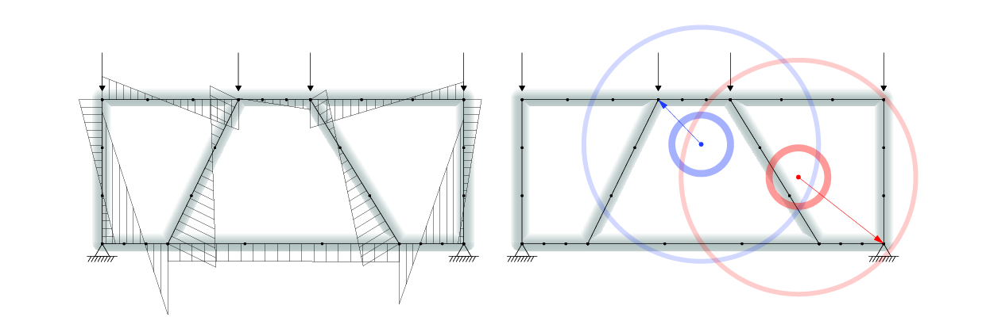

Figure X.

| Table 1. Parameters of the Case Studies | | |
| --- | --- | --- |
| Parameters | Case Study 1 | Case Study 2 |
| iterations* | 1000 | 500 |
| model diameter [m] | 3.32 | 33.17 |
| beams | 10 | 92 |
| pointloads[kN] | 100 | 100 |
| probe points per beam* | 4 | 4 |
| beam axis shift factor* | 0.1 | 0.15 |
| initial beam radius[cm]* | 8 | 26 |
| minimal beam radius threshold[cm]* | 3.3 | 5.2 |
| number of osteoblasts* | 20 | 20 |
| number of osteoclasts* | 20 | 20 |
| cluster limit* | - | 1 |
| vision radius of the agents[m]* | 1 | 6.5 |
| effect radius of the agents[m]* | 0.25 | 1.8 |
| agent speed[m]* | 0.1 | 0.65 |
| effect strength of the agents[cm]* | 0.1 | 0.25 |
| computation time[s]** | 22 |  |

* Obligatory initialization Arguments for the Algorithm, aside from lattice structure, loads and supports.

** GhPython on Intel(R) Core(™) i7-10875H, GeForce RTX 2070 with Max-Q, 32GB RAM

In the first case study, the load is applied to the frame through the upmost vertices, while the supports are placed at the vertices of the bottom corners. the supports allow for no degree of freedom. the result is a simple yet statically indeterminate (is it?) structure. The arguments listed in Table 1 have to be specified for the Algorithm to work the model. Optionally they can be set proportionally to the size of the total frame for easier use. Starting with the first iteration the Normal Force N and the Moment Forces My and Mz are calculated for all the probe points on each beam by *finite elements method* (FEM) [a] provided by grasshopper - karamba3d [reference]. The number of probe points can be seen as the resolution of the model. Given the initial radius and a circular cross-section the comparison stress is calculated for each probe point by the following Formula:

comparison stress = *32 /

where: ...

I=... interesting side note

no calculation of stiffness, no material

Largely unequal distribution of the initial comparison stress is the logical result of the probe points’ initialization with an equal radius [see graph x]. At this point, the specified number of osteoblast and osteoclast is initiated at random positions throughout the given frame. Osteoblasts target the probe point with the highest comparison stress within their vision radius and move towards them. Osteoclasts function similarly except for targeting the probe points of the lowest comparison stress. The movement vector is calculated by the following Formula:

where: …

This is to ensure the amplitude of movement is consistent throughout every iteration and for every target point. exemptions for the targeting function are added to prevent agents from overshooting the target point, to prevent agent clustering, and to prevent osteoclast from targeting probe points with a radius below the minimum threshold. The otherwise ensuing elimination of beams would mean a change of topology, which happens in natural ossification, but was intentionally excluded at this stage of the research. those movement mechanics are an approximation of the natural osteoblast and osteoclast migration. How exactly mechanical forces are translated into stimuli for bone remodeling is still debated in the scientific community. Some connected factors might be micro-cracks in the bone tissue, trapped osteocytes, bone morphogenetic proteins, and chemotaxis [b,c].

The core of this investigation is the translation of the natural bone remodeling process into an optimization of the lattice structure and the stress distribution. It is conducted by two relevant processes: a modification of the cross-sections and a modification of the beam axes. The cross-section modification, resembling the mineralization and demineralization of collagen, is done by a fixed addition and subtraction to the nearest probe point radius within the agents’ effect radius, defined by the agent effect strength (figure X). In consequence of the agents’ vision radius being much larger than the agents’ effect radius, the agents move to distant probe points, while modifying cross-sections in their path.

In natural bone remodeling, osteoblasts and osteoclasts are confined to move along the surface of the trabecular bone. inevitably the mineralization and demineralization on the stressed or destressed side of the trabeculae result in a slow shift or a more plate-like shape. Mainly because, while technically possible, the calculation of movement on a surface would multiply the computation time, this investigation allows unconstrained agent movement throughout the frame and represents the beam shape only by the radii for circular cross-sections. thereby the whole model can be represented only by numbers, points, and lines. Only after the last iteration, the beam radii are used to give the beams their volume. Cylindrical elements are proven to be able to simulate the load-bearing of the sometimes plate-like trabecular bone structure accurately[d] Yet the slow lateral shift, roughly comparable to the formation of dripstone (not exactly?), cannot be represented precisely without a change of the cross-section shape. To approximate the shifting effect, a method was introduced which rotates the beam axis. To do this the agents first checks on which side of the corresponding axis it is located and set the center of rotation to the opposite end. The moment Force M_res is calculated from M_y and M_z at the current position, relative to the beam coordinate system. the direction of the rotation is set opposite to the moment Force M_res at the current position, which is calculated by My and Mz at the current position and thereby moving the beam in the exact direction of the compressed side. The angle for the rotation set is proportional to the magnitude of moment M_res (inaccurate?). To keep the structural integrity of the model, a new node point is then interpolated between the rotated vertice and the previously connected other vertices(figure X). the node points connecting multiple beams had to be equalized for the lowest local comparison stress and the highest radius respectively to prevent osteoblasts and osteoclasts from getting locked into a ‘tug of war’ over different beams vertices incorporated in the same node.

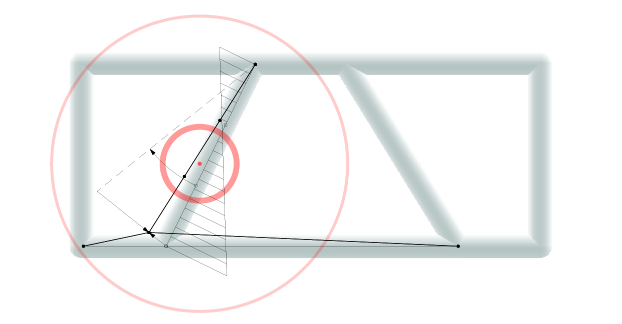

Figure X.

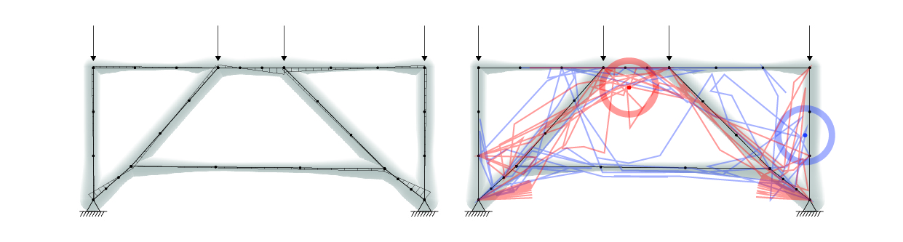

Figure X

Overall the areas with higher stresses will get a larger cross-sectional area and at the same time, the displacement of beam axes will lead to an orientation where the beam axis approaches an ideal line of thrust, to reduce bending moments to a minimum. To achieve this the Agents work for a specified number of Iterations. Each Iteration consists of the following successive steps: calculation of N, M_y, and M_z through FEM, calculation of comparison stress, equalization of comparison stress for the nodes points, movement targeting, movement, alteration targeting, radius alteration, axis alteration.

Each iteration completely loops through all of the agents and while the radius alteration does only change the resulting comparison stress, an axis alteration is a change of structure and would require a recalculation of the FEM model for every agent for every iteration. For Reasons of operability, the axis alterations are averaged and applied only once every iteration.

RESULTS

Table X shows a clear reduction of comparison stress throughout the model after 1000 iterations. The average comparison stress was reduced from 2.62 kN/cm² in the benchmark structure with uniform radii to 0.54 kN/cm² in the optimized structure. More importantly, the standard deviation of the comparison stress was reduced from 2.38 kN/cm² to 0.05 kN/cm², clearly indicating a more equal distribution of stress. Those improvements are caused by the radius alterations according to the local forces, which results in a less equal distribution of radii, visible in table X. The reduction in average bending moment force at the probe points from 6.72 kNm to 0.60 kNm is independent of the cross-section and solely caused by the axis alteration. the sum of beam volumes stayed roughly constant during the optimization, starting at 0.25m³, finishing at 0.29m³.

Since, unlike in natural ossification, the agent strength is equal for osteoblasts and osteoclasts, the increase of total volume by 16% might be caused by the node point equalization of all the connected beam endpoints, towards the highest radius. Defacto multiplying the strength of agents, which alter nodes.

The axis alteration and moment minimization is a qualitative progression of the method introduced by (Melcher et al). The change of platform from grasshopper to python yields a 334 times faster computation for a 2D structure with 94 beams on the same hardware and similar initialization parameters.

Table X shows the same indicators for the second Case Study, a three-dimensional lattice structure (figure X). The visible patterns(figure X) are closely comparable. It can be stated, that, for a two as well as a three-dimensional lattice structure, the algorithm achieves a significant(is it?) reduction and better distribution of comparison stress and bending moment forces.

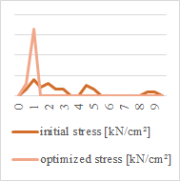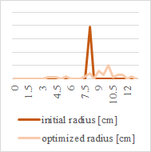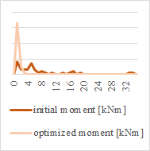

Figure X.

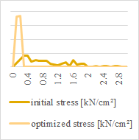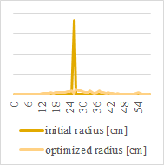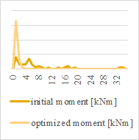

Figure X

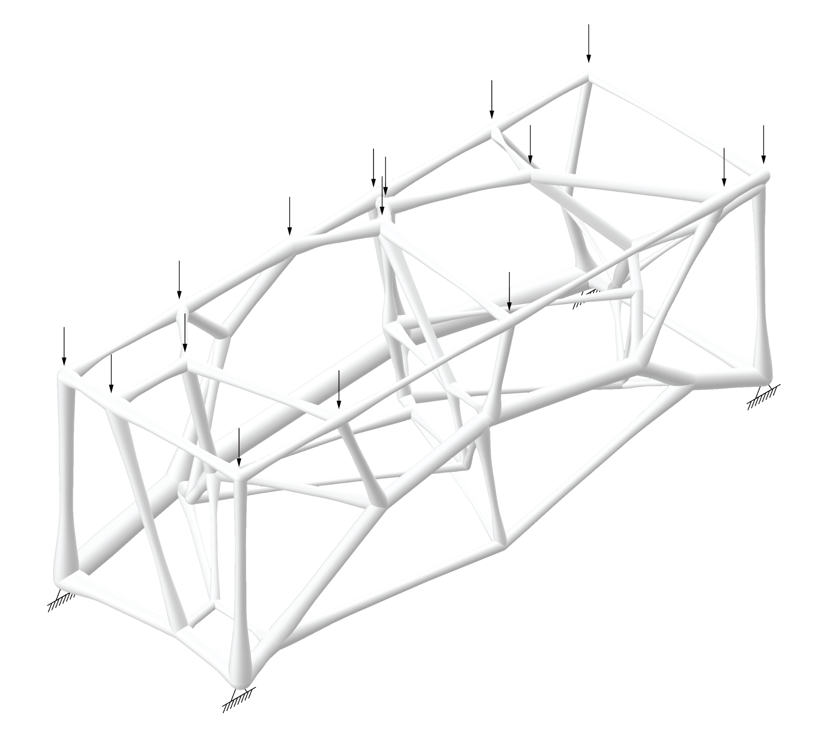

Figure X

CONCLUSION AND OUTLOOK

The calculated comparison stress(figure X) proves the algorithm is capable of shape and size optimization. When evaluating the resulting lattice structures(figure X) an adaption of the trabecular architecture along the tension and compression stress trajectories becomes apparent. The result of the second case study show similarities to a decked arch bridge, which would be a common optimization for such a load scenario, while the right arch even seems to be underspanned.

Yet the algorithm contains several inaccuracies on the technical level. Shear and torsion forces are not considered in the comparison stress calculation and could significantly alter the results. A constant total amount of tissue, represented by volume, during the optimization would simulate agents’ reuse of collagen and would require an application through a fixed amount of volume instead of radius. The shift of axis currently is subject to the magnitude of the moment, while it should be fixed and just be subject to the direction.

Overall the agent-based approach has several drawbacks. The artificial agents’ limited vision, limited movement, and limited strength make pose an additional processing layer and make it inferior to conventional structural optimization methods, where size and shape of the elements are the result of direct calculation. Nonetheless, natural ossification cannot be described in a single optimal state, but as a process of chronological actions influencing one another. This becomes evident by changing the starting point of a single agent, which has a non-linear impact and completely changes the outcome. The resulting structure then represents a different local optimum. An

agent-based approach, drawbacks

algorythm improvements:

* equal load distributino
* uneven distribution of probe points(depending on lenght)
* simultanious update?
* material application trough area not radius
* geometry input
* agent targetpoint considering distance(?)
* joints with multipipe
* agent balance research
* constant material (?)
* animation with changing loads
* initialize agents on probe_points
* train neural net by inputting only the graph and the forces
* shift permanently active

further research:

* reinforcement learning
* agent ratio/death/strength
* equalibrium calculation <- galapagos optimization
* structural adaptability within building parts
* taking into consideration only a one-dimensional material optimization, the target could be to achieve uniformly high utilization grades just below 1,0 in all members in the ultimate limit state (ULS)
* movement pattern comparison <- research into osteoblast and osteoclast migration

-> optimization for pressure, eliminating moments -> additive fabrication  
 ->simulation of osteoblast, osteoclast behaviour

->adabptive support structures, (yet, not implementable)

ossification

osteoblasts and osteoclasts will be refered to as agents

adapted ossification

nodes equalization description

movement pattern detection(abbildung)

results

conclusion

good knowledge of the model building parameters ->

[a] Desai, Y.M., Eldho, T.I., Shah, A.H.: Finite Element Method with Applications

in Engineering. Person, London (2011)

[b]Thiel, Antonia, Marie K. Reumann, Adele Boskey, Johannes Wischmann, Rüdiger von Eisenhart-Rothe, and Philipp Mayer-Kuckuk. ‘Osteoblast Migration in Vertebrate Bone’. *Biological Reviews of the Cambridge Philosophical Society* 93, no. 1 (February 2018): 350–63.<https://doi.org/10.1111/brv.12345>.

[c]Khurana, Jasvir S., and Fayez F. Safadi. ‘Bone Structure, Development and Bone Biology’. In *Essentials in Bone and Soft-Tissue Pathology*, by Jasvir S. Khurana, Edward F. McCarthy, and Paul J. Zhang, 1–15. Boston, MA: Springer US, 2010.<https://doi.org/10.1007/978-0-387-89845-2_1>.

[d]Lenthe, G.H. van, M. Stauber, and R. Müller. ‘Specimen-Specific Beam Models for Fast and Accurate Prediction of Human Trabecular Bone Mechanical Properties’. *Bone* 39, no. 6 (December 2006): 1182–89.<https://doi.org/10.1016/j.bone.2006.06.033>.

## Preisinger, C. (2013), *Linking Structure and Parametric Geometry*. Architectural Design, 83: 110-113 DOI: 10.1002/ad.1564.

[e]Maskery, I., A.O. Aremu, M. Simonelli, C. Tuck, R.D. Wildman, I.A. Ashcroft, and R.J.M. Hague. ‘Mechanical Properties of Ti-6Al-4V Selectively Laser Melted Parts with Body-Centred-Cubic Lattices of Varying Cell Size’. *Experimental Mechanics* 55, no. 7 (1 September 2015): 1261–72.<https://doi.org/10.1007/s11340-015-0021-5>.

Topology optimization:

Bendsoe & Kikuchi 1988: Generating optimal topologies in structural design using homogenization

Im Mensch oder Tier (in vivo), oder auch in der Gewebekultur (in vitro)

homogeneus isotropic material… no material

The

bending stiffness is the product of two factors: one describes the

stiffness of the material, i.e. the elastic modulus, E; the second factor is

a geometrical factor, the second moment of area, I [44]. This factor

characterizing the structure is calculated as

I = ∫A

x2dA;

**Introduction / State of research**

-> optimization for pressure, eliminating moments -> additive fabrication  
 ->simulation of osteoblast, osteoclast behaviour

->adabptive support structures, (yet, not implementable)

Topology optimization:

Bendsoe & Kikuchi 1988: Generating optimal topologies in structural design using homogenization

**Natural Ossification Process**

* tube type bones in mammal skeletons are lightweight and efficient structures
* made of a tube-like outer shell (cortex) with a more spongy core zone, that is made up of of filaments
* filaments in the bone matrix consist of ossein fibres (a kind of collagen) of a high strength and elasticity
* distribution and density of the bone matrix depends on the magnitude of forces that have to be transferred through that particular part of the bone
* classic examples for these are the spongy bone structures in the articulation zones of long bones e.g. femur or humerus
* construction and destruction of the bone fibers is managed by two main types of cells, the osteoblasts and osteoclasts
* osteoblasts create new bone substance by adding hardening osteoid, while osteoclasts remove material from the bone
* by this mechanism, the filaments can gradually increase or decrease their cross-section and also change their geometry if new material is mainly added laterally
* thus, the bone matrix can not only adapt material to highly stressed areas, but also change the topology of the structure - and this is also the subject of this paper

**The adapted Ossification process**

* basis: a 3-dimensional lattice structure filling a given volume
* topology and density of this structure are determined a priori. Different approaches may be employed for this, e.g. regular orthogonal or hexagonal grids, or regular crystalline packing like 1/2O-T structures or 1/2O-1/2CO structures (nomenclature see Wachsmann 1944?)
* for the purpose of the following investigation, a network is created from Voronoi cells, generated from randomly distributed vortex points
* members get round solid cross section
* load application to the volume: in defined points or uniformly on one surface with distribution to the vortices that are in the surface
* calculation of forces in the structure at defined points of each member (deciles/10 points per member): Normal forces, Bending moments M_y, M_z (with the help of grasshopper - Karamba)
* calculation of comparison stress for each point (FORMULA!)
* optimization of the lattice is conducted by two relevant processes: an adaptation of the cross sections and the adaptation of the girder axes
* osteoblast: obervation radius + effect radius
* movement of osteoblast: how?
* increase or decrease of diameter by fixed amount
* lateral movement of beam axis: calculation of a resulting moment M_res from M_y and M_z, calculation of angle of this bending moment relative to the beam coordinate system, movement of beam origin in the exact direction of the compressed side of the beam; amount of movement proportional to magnitude of moments
* thus, areas with higher stresses will get a larger cross-sectional area, and so in next iteration stresses will decrease there
* at the same time, the displacement of beam axes will lead to an optimum where beam axis get close to an ideal line of thrust (with very minimal bending moments)

**conclusion and Outlook**

The proposed optimization method represents one possible way to create a lattice with a geometry and cross sections adapted to force flow in a given volume. The optimization of cross-sections, however, yields only qualitative results, since material properties like Young’s modulus and yield strength were not taken into account.

What a refined model should account for:

* taking into account torsion and shear stresses in the cross-section
* critical buckling load (e.g. with slenderness, and calculative increase of actual stresses with k-factors)
* implement a mechanism to maximise stresses in cross sections without

At an ultrastructural level,

bone is organized to maximally resist applied mechanical

forces. Calcium hydroxyapatite crystals are arranged parallel

to collagen fibers (59). This orientation maximizes the

collagen’s resistance to tensile (stretch) forces and the calcium

hydroxyapatites resistance to compressive forces.

Every change in form and function of bones,

is followed by changes in the internal architecture and external

conformation, in strict accordance with mathematical

laws (Julius Wolff, 1882). wolffs law

Weightlessness in space causes rapid decrease in

bone mass reflecting the need for constant force in maintaining

skeletal bone.

All these examples illustrate the close link of mechanical

forces with skeletal response and bone formation. What is

still under investigation, however, is how these mechanical

forces are translated into cellular events. It is likely, that

signaling mechanisms, such as electricity or chemical messengers,

such as certain cytokines, mediate these responses.

Computer controlled membranes holding tissue cultures

of osteoblasts and fibroblasts have been used to alter the

amounts of “stretch” provided to the cells. These studies have

suggested that there is an altered metabolism and DNA synthesis

under conditions of load. It has been suggested

(292–294) that there may be two components to this system:

The Cell Network: This consists of osteocytes and their

processes in communication with surface cells. Stretch sensitive

ion channels are thought to exist on osteoblasts and

fibroblasts.

The Mineralized Matrix: Stream generated potentials are

created when fluid flowing through the matrix carries along

a species of ion (in the presence of another species attached

to the matrix).

These two mechanisms may be responsible for the signal

for altered cellular metabolism observed. A “piezo-electric”

effect as a result of compression of the hydroxyapatite crystal

is also theoretically possible, but unlikely to be responsible

for the coupling of mechanical-electric phenomena in

bone.

The mechanism by which strain induces osteoblast proliferation

in strain studies has thought to be mediated by the

inositol 1,4,5 triphosphate system (295–296). Inhibition of

phospholipase C (by neomycin) blocks inositol triphosphate

production and subsequent proliferation. Additional signaling

pathways (such as by cyclic AMP) may co-exist.

There is a hypothesis that cells maintain a basal equilibrium

stress state that is a function of the number and quality

of focal adhesions, the polymerization of the cytoskeleton

and the amount of extrinsic applied mechanical deformation

(297). A load stimulus detected by a mechano-electrochemical

sensory system (including stretch sensitive ion-channels,

integrin cytoskeletal machinery, and load-conformational

sensitive receptor tyrosine kinase) activates G proteins,

induces second messengers,

INTRODUCTION

1.1 Ossification is a biological process that optimizes the bones structure by two main organic actors: *osteoblasts* and *osteoclasts*. By mineralization and demineralization of *filaments* forming the inner bone matrix, these actors control the balance between stability and lightweight during the lifetime of the bone. There has been a global awareness of knowledge transformation from biological observation into technology in the past decades, namely *bionics*. We can witness a wide usage of biologically inspired ideas in the development of building structures. The benefits are apparent: more stability for less material, optimized production methods and more design options.

This paper's research ground is the work by *A. Melcher and others* who developed a principle for *artificial ossification* and its possible application in building construction. This principle is based on the random initialization of a three- dimensional porous network of filaments inside a fixed outer form. Filaments are cylindrical and can change their thickness or disappear during the process. This network is exposed to external forces and the resulting mechanical stress is determined by a *finite elements method* (FEM). Now, artificial osteoclasts and osteoblasts that have been randomly placed in the filament network are starting their operation: reducing and strengthening cylindrical filaments, similar to its corresponding natural behavior.

Most conventional FEM software today provides biologically inspired topology optimization methods, which utilize the *Soft Kill Option* (SKO). The SKO method perforates a solid design space by calculating the tension of its elements. Considering the *E-modulus*, soft elements get eliminated until it solves for homogeneous stress distribution. Instead, our approach aims at a more close emulation of the biological process inside a network capable of mass accumulation and reduction. The force behind the actor's movement along the above described initial model's filament network is the stress at filament junctions that differs from the SKO method, where every element is under the same treatment.

Some of the recognized limitations of the previous research are the filament abstraction and rigid network structure that were necessary due to simplicity for principal investigations. It can be observed that the internal deformation of the filaments is limited and does not correspond to natural growth. In nature, filaments will change their position over time and have various transformations. These transformations can result in having more voluminous but porous ends in contrast to thinner, denser, and longer bodies. This mobility of the inner structure is directly influencing the structural capabilities of the whole system.

This paper is mainly focusing on applying natural behavior in the transformation of filaments during their lifetime. This demands a higher deformational resolution of the artificial filaments and variable filament axes that will change in dependency of attached or detached material. Furthermore, the artificial ossification algorithm has been optimized and rewritten due to added operations and high computation costs, and the problem of eliminating locally trapped osteoblasts and osteoclasts has been solved. The paper will present several case studies of structural solutions and make a comparative analysis with SKO solutions.